REGISTRATION FORM OF 7th GCBSS CONFERENCE 2018
20-21 August 2018, Cinnamon Grand Hotel Colombo Sri Lanka
http://gcbss.org/cimssr2018/registration-payment.html

7th GCBSS will be held during 20-21 August 2018, Cinnamon Grand Hotel Colombo Sri Lanka. Please note that it is essential for all participants to email the filled Registration Form (.doc/.docx/pdf) along with Proof of payment receipt to ids: register@gatrenterprise.com and Cc to admin@gcbss.org

SECTION 1: CONTACT INFORMATION
Paper ID Code: For example, CIMSSR-00101
Name that you would like to get printed on the certificate:

Conference Title: 7th Global Conference on Business and Social Science, Colombo Sri Lanka.
Whether attend the Conference: € Yes € No
Position (Professor/Associate Prof/Assistant Professor/Lecturer/PhD Student/Master Student/other):

Full Affiliation/Organization/University and country Name:
(that you like get printed on the certificate)

Broad Field: i.e. Accounting |  | Are you willing to serve as a session chair:(Yes (No
Session Type: € Oral Presenter € Participant (Without paper) € Visual Presenter
Telephone: | Mobile: |  | Email:
Special Needs or Dietary Requirements: € Yes € No
Student ID Number of Your University (if applicable):
Paper Title:
Paper Pages: |  | Additional Page:

Notes:
- One regular registration can cover a paper within 8 pages, including all figures, tables, and references at 1.5 line spacing. If the length exceeds 8 pages the authors are required to pay a publication fee of USD 25.00 for each additional page.

- If number of authors are more than two in manuscript authors are required to pay additional fees USD 50 for each additional author name.

- For additional Certificates for co-authors needs to pay USD 100 for each additional certificate.

SECTION 2: REGISTRATION FEESINFORMATION

Fee Schedule for 7th GCBSS Delegates: | Early  Until: 15/05/2018 | Normal  Until:  10/07/2018 | Late  Until: 10/08/2018
Regular Presenter (Lead Author) / Co-author | USD 525 | USD 550 | USD 600
Visual Presenter (Using Skype) | USD 525 | USD 550 | USD 600
Full Time Student | USD 425 | USD 450 | USD 500
Participant (Without paper) | USD 350 | USD 375 | USD 400
Additional Events for 7th GCBSS Delegates:
Dean & Directors Networking Session | USD 100 | USD 150 | USD 175
Workshop on Publishing in High Impact Factor (SSCI & SCI) Indexed Journals  Only 15 Seats | USD 75 | USD 100 | USD 120
Workshop on writing PHD and Research Grant Proposals  Only 15 Seats | USD 75 | USD 100 | USD 120
Both Workshop (Publishing in ISI and Proposals Writing)  Only 15 Seats each | USD 120 | USD 170 | USD 210

GATR/GCBSS Policy:

- The lecturer cum student will not be considered for student rate
- Full-time student must need to submit a valid student ID card
- Daily Market Conversion Rate is applicable to all USD prices.
- Service/Transfer Fees are not included in above prices.

Registration fee of Regular/Visual/Student Presenter Included:

Welcome Reception on 19 August 2018

7:00 PM to 8:30 PM (Cinnamon Grand Hotel)

- Printed name card, Note book
- Conference bag & Pen
- Presenter certificate (Printed & Electronic)
- Journal publication fees (Sponsored by GATR)
- Refereed Abstract Proceeding CD with ISBN
- Printed program Schedule
- Two coffee breaks each day
- International Buffet lunch daily

Registration fee of Observer Included:

Welcome Reception on 19 August 2018

7:00 PM to 8:30 PM (Cinnamon Grand Hotel)

- Card holder, Printed name card
- Conference bag & Pen
- Printed program Schedule
- Two coffee breaks each day
- International Buffet lunch daily

SECTION 3: PAYMENT INFORMATION

Option 1

You can pay registration fee by Bank Deposit / ATM Transfer / Online Transfer / Telegraphic Transfer in Company official account.

Please Visit: http://gcbss.org/cimssr2018/registration-payment.html
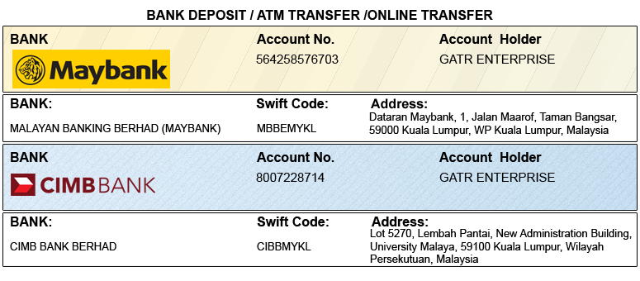

Option 2

You can pay registration fee through 2checkout Credit Card /Debit Card/PayPal in Company official account.
Please visit: http://gcbss.org/cimssr2018/registration-payment.html

PRIVACY POLICY:

The Global Academy of Training & Research (GATR) Division will protect your personal information. Your personal information received will only be used to fill your order. We will not sell or redistribute your information to anyone.

CANCELLATION POLICY:

You may cancel without penalty if written cancellation request is received up to and including 45 days prior to the start of the conference. A credit voucher less 50% of the registration fee will be issued for written requests received up to and including 25 days prior to the start of the conference. No refunds or credits will be issued on cancellation requests received less than 25 days prior to the start of the event. No liability is assumed by Global Conference on Business and Social Science for changes in program, date, content, speakers or venue.

PLEASE NOTE: Receipts will be provided on the Networking Session registration day (Dec 5, 2017) unless urgently required.

Declaration: I agree that I cannot claim back the registration fee I paid under any circumstance.
SIGNED:  (or write name here) |  | DATE:

