REGISTRATION FORM OF 6th GCBSS CONFERENCE 2017
4-5 December 2017, Ambassador Hotel, Bangkok, Thailand
http://gcbss.org/cibssr2017/registration-payment.html

6th GCBSS will be held during 4-5 December, 2017, Ambassador Hotel Bangkok. Please note that it is essential for all participants to email the filled Registration Form (.doc/.docx/pdf) along with Proof of payment receipt to ids: admin@gcbss.org and Cc to gcbss2017@gmail.com

SECTION 1: CONTACT INFORMATION
Paper ID Code: For example CIBSSR-00101
Name that you would like get printed on the certificate:

Conference Title: 6th Global Conference on Business and Social Science, Bangkok, Thailand.
Whether attend the Conference: € Yes € No
Position (Professor/Associate Prof/Assistant Professor/Lecturer/PhD Student/Master Student/other):

Full Affiliation/Organization/University and country Name:
(that you like get printed on the certificate)

Broad Field: i.e. Accounting |  | Are you willing to serve as a session chair:(Yes (No
Session Type: € Oral Presenter € Participant (Without paper) € Visual Presenter
Telephone: | Mobile: |  | Email:
Special Needs or Dietary Requirements: € Yes € No
Student ID Number of Your University (if applicable):
Paper Title:
Paper Pages: |  | Additional Page:

Notes:
- One regular registration can cover a paper within 8 pages, including all figures, tables, and references at 1.5 line spacing. If the length exceeds 8 pages the authors are required to pay a publication fee of USD 25.00 for each additional page.

- If number of authors are more than two in manuscript authors are required to pay additional fees USD 50 for each additional author name.

- For additional Certificates for co-authors needs to pay USD 100 for each additional certificate.

SECTION 2: REGISTRATION FEESINFORMATION

Fee Schedule for 6th GCBSS Delegates: | Early  Until: 30/08/2017 | Normal  Until:  15/10/2017 | Late  Until: 15/11/2017
Regular Presenter | USD 525 | USD 550 | USD 600
Visual Presenter (Using Skype) | USD 525 | USD 550 | USD 600
Full Time Student (Proof of Student card is required) | USD 425 | USD 450 | USD 500
Participant (Without paper) | USD 350 | USD 375 | USD 400
Additional Events for 6th GCBSS Delegates:
Dean & Directors Networking Session on 5th Dec., 2017 | USD 100 | USD 150 | USD 175
Workshop on Publishing in ISI (SSCI & SCI Indexed) Journals on 5th Dec., 2017 | USD 100 | USD 125 | USD 150
Bangkok Conference Tour on 6th Dec., 2017 | USD 50 | USD 75 | USD 100

GATR/GCBSS Policy:

- The lecturer cum student will not be considered for student rate
- Full-time student must need to submit a valid student ID card
- Daily Market Conversion Rate is applicable to all USD prices.
- Service/Transfer Fees are not included in above prices.

Registration fee of Regular/Visual/Student Presenter Included:

Admission to the welcome reception and parallel session

- Conference KIT (includes: bag, notebook, pen, name card)
- Printed presenter certificate
- Refereed Proceeding CD or USB with ISBN
- Journal publication fees (Sponsored by GATR)
- Printed brief program Schedule
- Two coffee breaks each day
- International Buffet lunch daily

Registration Fee of Participant Included:

Admission to the welcome reception and parallel session

- Conference KIT (includes: bag, notebook, pen, name card)
- Printed participant certificate
- Printed brief program Schedule
- Two coffee breaks each day
- International Buffet lunch daily

SECTION 3: PAYMENT INFORMATION

Option 1

You can pay registration fee by Bank Deposit / ATM Transfer / Online Transfer / Telegraphic Transfer in Company official account.

Please Visit: http://gcbss.org/cibssr2017/registration-payment.html
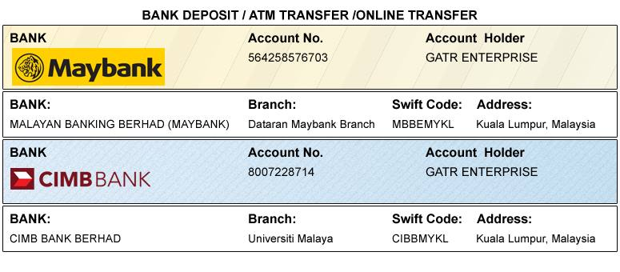

Option 2

You can pay registration fee through 2checkout Credit Card /Debit Card/PayPal in Company official account.
Please visit: http://gcbss.org/cibssr2017/registration-payment.html

PRIVACY POLICY:

The Global Academy of Training & Research (GATR) Division will protect your personal information. Your personal information received will only be used to fill your order. We will not sell or redistribute your information to anyone.

CANCELLATION POLICY:

You may cancel without penalty if written cancellation request are received up to and including 45 days prior to the start of the conference. A credit voucher less 50% of the registration fee will be issued for written requests received up to and including 25 days prior to the start of the conference. No refunds or credits will be issued on cancellation requests received less than 25 days prior to the start of the event. No liability is assumed by Global Conference on Business and Social Science for changes in program, date, content, speakers or venue.

PLEASE NOTE: Receipts will be provided on the Networking Session registration day (Dec 5, 2017) unless urgently required.

Declaration: I agree that I cannot claim back the registration fee I paid under any circumstance.
SIGNED:  (or write name here) |  | DATE:

