4TH ANNUAL GLOBAL CONFERENCE ON BUSINESS AND SOCIAL SCIENCES (4th GCBSS 2016)

DEANS & DIRECTORS REGISTRATION FORM

November 14-15, 2016, Radisson Hotel, Dubai (United Arab Emirates)
http://gcbss.org/cibssr/index.html

4TH Annual Global Conference on Business and Social Sciences 2016 will be held during 14th – 15th November, 2016 in Radisson Blu hotel Dubai, UAE. Please submit the filled Registration Form (.doc/.docx/), Proof of payment receipt to ids: gcbss2016@gmail.com and Cc to admin@gcbss.org

SECTION 1: CONTACT INFORMATION:
Paper ID Code: For example CIBSSR-00401
Name that you would like get printed on the certificate:

Conference Title: 4th Annual Global Conference on Business and Social Sciences
Plan to attend the conference: € Yes € No
Designation: (VC/Rector/Dean/Director/Professor/Assoc. Professor/ Head of Department/other):

Full Affiliation/Organization/University and country Name:
(that you like to get printed on the certificate)

Telephone: | Mobile: |  | Email:
Special Needs or Dietary Requirements: € Yes € No
Conference Track: i.e. Finance |  | Are you willing to serve as a session chair: (Yes (No
Session Type: € Oral Presenter € Participant (Without Paper)
Paper Title:
Paper Pages: |  | Additional Page:

Note:
- One regular registration can cover a paper within 8 pages, including all figures, tables, and references. If the length exceeds 8 pages the authors are required to pay a publication fee of USD 20.00 for each additional page.

- If number of authors are more than four in manuscript authors are required to pay additional fees USD 50 for each additional author name.

- For additional Certificates for co-authors needs to pay USD 100 for each additional certificate.

SECTION 2: REGISTRATION FEES INFORMATION:

Deans & Directors Registration Fee | Early Bird  Until: 25 July, 2016 | After  28 July, 2016 | After  25 Sep., 2016
Regular Presenter | USD 550 | USD 600 | USD 625
Regular Participant (without Paper) | USD 525 | USD 575 | USD 600
Additional Events:
Post Conference workshop on Publishing in ISI Journals by Plenary Speakers: (16 Nov, 2016) | USD 150 | USD 175 | USD 200
Conference Tour (17 Nov, 2016) | USD 100 | USD 120 | USD 125

Deans & Directors Registration includes:
- Exclusive, expedited check-in at the 4th GCBSS Opening Session.
- Reserved front row seating at the General Session & Opening Keynote, Award Luncheon and Conference Finale.
- Conference name badge, Proceeding CD and materials delivered to your hotel.
- Printed program schedule.
- Annual DD Networking Session E-Ticket.
- Sovereign in Closing Ceremony.

- Journal publication fees (Sponsored by GATR)

SECTION 3: PAYMENT INFORMATION:

Option 1: You can pay registration by Bank Deposit / ATM Transfer / Online Transfer / Foreign Telegraphic Transfer.

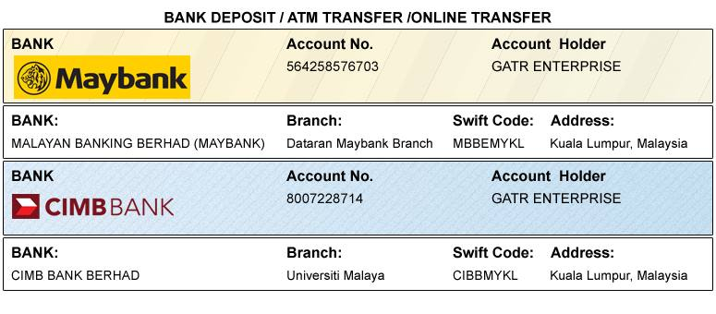

Option 2 PayPal / Credit Card / Debit Card:

If you have a credit card or 2checkout account, we strongly encourage you to pay the fee through 2checkout. 2checkout enables users, whether or not they are 2checkout members, to use all major credit cards, including Visa, Master card, American Express, and Discover. 2checkout is fast and secure. Please visit how to pay at: http://gcbss.org/cibssr/registration-payment.html

PLEASE NOTE: Receipts will be provided on the conference registration day (14 November, 2016) unless urgently required.
SIGNED:  (or write name here) |  | DATE:

